* [Operational Overview](https://confluence.schroders.com/display/GCFN/Support" \l "Support-OperationalOverview)
  + [Process Descriptions:](https://confluence.schroders.com/display/GCFN/Support#Support-ProcessDescriptions:)
  + [Static Data Load Overview](https://confluence.schroders.com/display/GCFN/Support#Support-StaticDataLoadOverview)
  + [Cash Flow Data Load Overview](https://confluence.schroders.com/display/GCFN/Support#Support-CashFlowDataLoadOverview)
  + [Aladdin Export Overview](https://confluence.schroders.com/display/GCFN/Support#Support-AladdinExportOverview)
* [Infrastructure Overview](https://confluence.schroders.com/display/GCFN/Support#Support-InfrastructureOverview)
* [Open Questions](https://confluence.schroders.com/display/GCFN/Support#Support-OpenQuestions)
* [Component Identity Cards](https://confluence.schroders.com/display/GCFN/Support#Support-ComponentIdentityCards)
  + [Load Fund Hierarchy](https://confluence.schroders.com/display/GCFN/Support#Support-LoadFundHierarchy)
  + [Load Exchange Rates](https://confluence.schroders.com/display/GCFN/Support#Support-LoadExchangeRates)
  + [Load NAVs](https://confluence.schroders.com/display/GCFN/Support#Support-LoadNAVs)
  + [Load Cash Flow from other TA](https://confluence.schroders.com/display/GCFN/Support#Support-LoadCashFlowfromotherTA)
  + [Load Collateral Movements (SIMLUX)](https://confluence.schroders.com/display/GCFN/Support#Support-LoadCollateralMovements(SIMLUX))
  + [Load Cash Flow from SIMLUX](https://confluence.schroders.com/display/GCFN/Support#Support-LoadCashFlowfromSIMLUX)
  + [Load Data into FundSphere](https://confluence.schroders.com/display/GCFN/Support#Support-LoadDataintoFundSphere)
  + [Export Data to Export Database](https://confluence.schroders.com/display/GCFN/Support#Support-ExportDatatoExportDatabase)
  + [Create and Distribute the Aladdin export file](https://confluence.schroders.com/display/GCFN/Support#Support-CreateandDistributetheAladdinexportfile)

Operational Overview

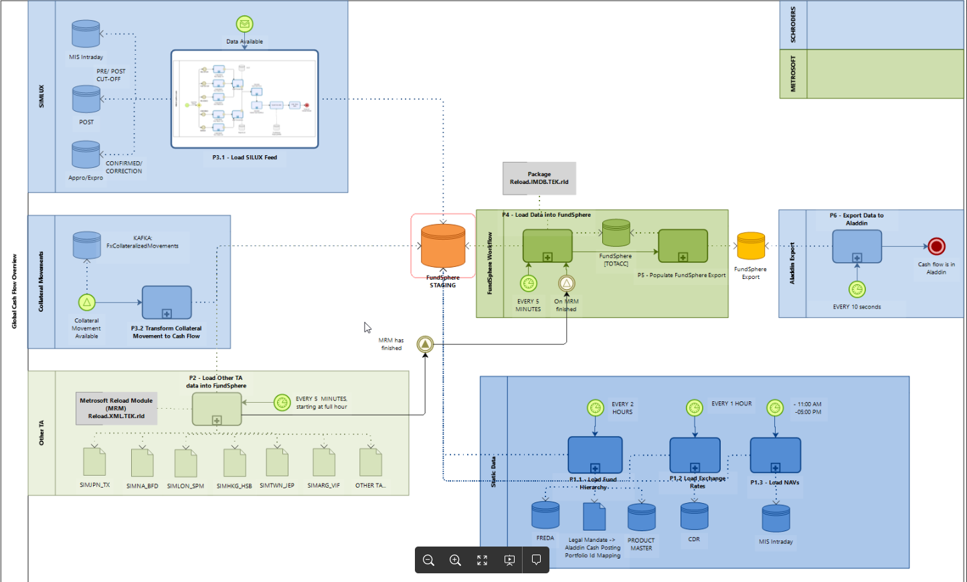

**Process Descriptions:**

* Static Data Load
  + **P1.1** - Load Fund Hierarchy: see also [Load Fund Hierarchy Data](https://confluence.schroders.com/display/GCFN/Load+Fund+Hierarchy+Data).
  + **P1.2** - Load Exchange Rates: see also [Load Exchange Rate Data](https://confluence.schroders.com/display/GCFN/Load+Exchange+Rate+Data).
  + **P1.3** - Load NAVs: see also [Load NAV data](https://confluence.schroders.com/display/GCFN/Load+NAV+data).
* Cash Flow Data Load:
  + **P2** - Load cash flow from other TAs: [2 - Cash Flows of Other TA](https://confluence.schroders.com/display/GCFN/2+-+Cash+Flows+of+Other+TA).
  + **P3.1** - Load SIMLUX cash flow data: [3 - Cash Flows from SIMLUX Feed](https://confluence.schroders.com/display/GCFN/3+-+Cash+Flows+from+SIMLUX+Feed).
  + **P3.2** - Load Collateral Movement cash flow data [Collateral Movements](https://confluence.schroders.com/display/GCFN/Collateral+Movements)
* FundSphere Processes
  + P4 - Load Data into FundSphere (from staging into TOTACC)
  + P5 - Export data o Export Database
* Aladdin related Processes
  + **P6** - Create and distribute Aladdin export file.

 The BAU follows the numbering, while P2 -P6 is a loop by TA and flow type

**Static Data Load Overview**

Taking the big picture apart, before cash flow data can be consumed by FundSphere, Company must ensure that all necessary static data is available. This is covered through processes:

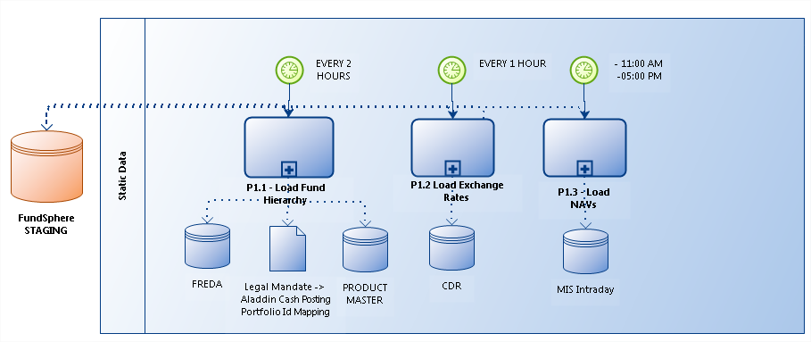

Static Data Load

* **P1.1** - Load Fund Hierarchy: see also [Load Fund Hierarchy Data](https://confluence.schroders.com/display/GCFN/Load+Fund+Hierarchy+Data).
* **P1.2** - Load Exchange Rates: see also [Load Exchange Rate Data](https://confluence.schroders.com/display/GCFN/Load+Exchange+Rate+Data).
* **P1.3** - Load NAVs: see also [Load NAV data](https://confluence.schroders.com/display/GCFN/Load+NAV+data).

**Cash Flow Data Load Overview**

As mentioned in the introduction of the project, having cash flow data centralized is an essential driver. Since more than 14 different providers are supposed

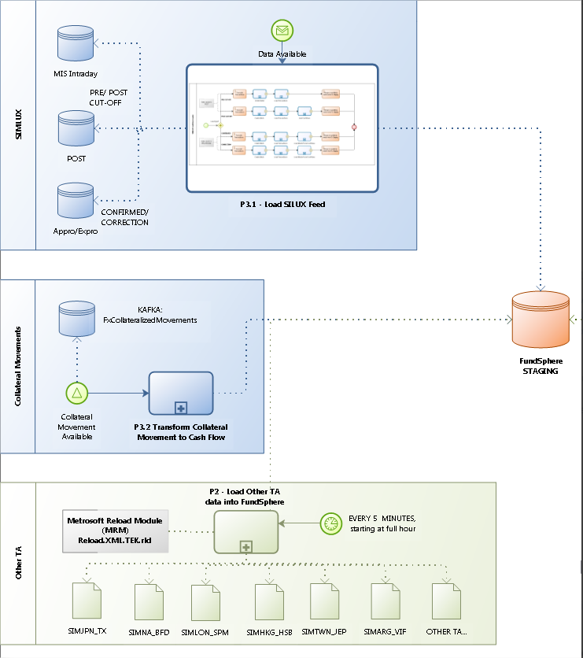

* **P2** - Load cash flow from other TAs: [2 - Cash Flows of Other TA](https://confluence.schroders.com/display/GCFN/2+-+Cash+Flows+of+Other+TA).
* **P3.1** - Load SIMLUX cash flow data: [3 - Cash Flows from SIMLUX Feed](https://confluence.schroders.com/display/GCFN/3+-+Cash+Flows+from+SIMLUX+Feed).
* **P3.2** - Load Collateral Movement cash flow data [Collateral Movements](https://confluence.schroders.com/display/GCFN/Collateral+Movements)

Please note:

* From FundSphere's point of view, there are 4 flow types: pre cut-off, post cut-off, confirmed andcorrection
* Collacteral movements are provided only as collateral flows
* Not all TAs (including SIMLUX) provide all flow types for all the funds
* The timings and which feed is expected to arrive when can be found at [2.1 - Cash Flows of Other TA](https://confluence.schroders.com/display/GCFN/2.1+-+Cash+Flows+of+Other+TA)

**Aladdin Export Overview**

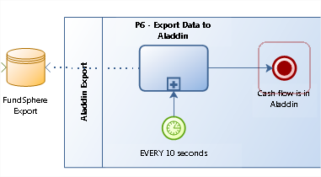

Aladdin related Processes

* **IN P2**
* **IN P3.x**
* **OUT: P6** - Create and distribute Aladdin export file.

Please note:

* Data which arrives in FundSphere is **almost immediately** scheduled for Aladdin export. In order to keep gap-times low, the Aladdin export is scheduled for every 10 seconds.

Infrastructure Overview

|  |  |
| --- | --- |
| **DB-SERVER** |  |
| Roles:   * Sql Server 2008 R2 SP3 * AE Proxy | * 350GB Storage in total, details:   + **C:** SYSTEM, 70GB   + **E:** DATA, LOGS, 200GB   + **F:** Backup, 100GB   + **G:** TempDB, 50GB |
| **APP-SERVER** |  |
| Roles:   * Archive Engine * Configuration * Web-App Server (FundSphere Navigator) * Reload Module | Hardware:   * 50 GB Storage in total, details:   + **C**: SYSTEM, 70GB   + **D**: LOGS, 50GB |
| **INTEGRATION SERVICES** | **(with Company)** |
| Roles:   * Fund Hierarchy Loader * NAV Loader * Exchange Rate Loader * SIMLUX feed loader * Collateral Movement Loader | Hardware:   * **Part of Service Fabric Cluster** |

Open Questions

* Contact (SPOC) on Metrosoft side
* Contact (SPOC) on TA SIMLUX side
* Contact (SPOC) on Cash Flow Notification Team Side

Component Identity Cards

**Load Fund Hierarchy**

| **Description:** | **Component which loads share class, legal fund and legal entity into FundSphere** |
| --- | --- |
| **Id** | **fabric:/SIMProduct.FundSphere/FundSphere.LoadFund** |
| **Processes Owned** | 1.1 |
| **Type** | Service Fabric - Quartz Driven Service |
| **Execution Scheme** | Scheduled in dimension 'hours' |
| **Dependencies** | * Database.Freda, * Database.FundSphere_Staging * Aladdin Cash Posting Portfolio Mapping File * Service Fabric Cluster * Product Master Service |
| **Responsible Parties** | Company, Cash Flow Team |

**Load Exchange Rates**

| **Description:** | **Component which all exchange rates for a given day into FundSphere Staging** |
| --- | --- |
| **Id** | **fabric:/SIMProduct.FundSphere/FundSphere.LoadExchangeRate** |
| **Processes Owned** | 1.2 |
| **Type** | Service Fabric - Quartz Driven Servic |
| **Execution Scheme** | Scheduled in dimension 'hours' |
| **Dependencies** | * Database.CDR, * Database.FundSphere_Staging * Service Fabric Cluster |
| **Responsible Parties** | Company, Cash Flow Team |

**Load NAVs**

| **Description:** | **Component which net asset values for a given day into FundSphere Staging** |
| --- | --- |
| **Id** | **fabric:/SIMProduct.FundSphere/FundSphere.LoadNAV** |
| **Processes Owned** | 1.3 |
| **Type** | Service Fabric - Quartz Driven Service |
| **Execution Scheme** | Scheduled in dimension of half-days |
| **Dependencies** | Infrastructure:   * Database.Freda, * Database.FundSphere_Staging * Component 'Load Fund Hierarchy' * Service Fabric Cluster |
| **Responsible Parties** | Company, Cash Flow Team |

**Load Cash Flow from other TA**

| **Description:** | **METROSOFT - Component which picks-up a file from a configured location and populates the FundSphere Staging and core databases.** |
| --- | --- |
| **Id** | **Reload.XML.TEK.rld** |
| **Processes Owned** | 2 |
| **Type** | Executable |
| **Execution Scheme** | Scheduled in dimension of half-days |
| **Dependencies** | Infrastructure   * Database.FundSphere_Staging * Database.FundSphere_IMDB * Database.FundSphere_TOTACC * Database.FundSphere_Export * FATS * Service Fabric Cluster   Process:   * P1,1: 'Load Fund Hierarchy' * P1.2: 'Load Exchange Rates' * P1.3: 'Load NAVs' |
| **Responsible Parties** | Metrosoft, Trading Agency, Company FATS & Cash Flow Teams |

**Load Collateral Movements (SIMLUX)**

| **Description:** | **Component which listens to a Collma topic in order to register the cash flow inside FundSphere.** |
| --- | --- |
| **Id** | [fabric:/SIMProduct.FundSphere/FundSphere.LoadCollateralMovement](http://fabric/SIMProduct.FundSphere/FundSphere.LoadTransferAgencyLU) |
| **Processes Owned** | 3.2 |
| **Type** | Service Fabric Service |
| **Execution Scheme** | On-demand, on request |
| **Dependencies** | Infrastructure:   * Database.FundSphere_Staging * Service Fabric Cluster   Process:   * P1,1: 'Load Fund Hierarchy' * P1.2: 'Load Exchange Rates' * P1.3: 'Load NAVs' * External: OCA sending signal to SIMLUX Loader (see P3.1, 'Data Available' |
| **Responsible Parties** | Company, Cash Flow Team if correct message arrives, but doesn't get imported  Company, Public Asset Team if no or incorrect message arrives |

**Load Cash Flow from SIMLUX**

| **Description:** | **Component which reads requested cash flows from Company databases.** |
| --- | --- |
| **Id** | fabric:/SIMProduct.FundSphere/FundSphere.LoadTransferAgencyLU |
| **Processes Owned** | 3.1 |
| **Type** | Service Fabric Service |
| **Execution Scheme** | On-demand, on request |
| **Dependencies** | Infrastructure:   * Database.FundSphere_Staging * Service Fabric Cluster   Process:   * P1,1: 'Load Fund Hierarchy' * P1.2: 'Load Exchange Rates' * P1.3: 'Load NAVs' * External: OCA sending signal to SIMLUX Loader (see P3.1, 'Data Available' |
| **Responsible Parties** | Company, Cash Flow Team |

**Load Data into FundSphere**

| **Description:** | **METROSOFT - Component moves, transforms data from FundSphere Staging into the FundSphere databases.** |
| --- | --- |
| **Id** | **Reload.IMDB.TEK.rld** |
| **Processes Owned** | 4 |
| **Type** | Executable |
| **Execution Scheme** | Scheduled in dimension of minutes/ on-demand |
| **Dependencies** | Infrastructure   * Database.FundSphere_Staging * Database.FundSphere_IMDB * Database.FundSphere_TOTACC * Database.FundSphere_Export |
| **Responsible Parties** | Metrosoft |

**Export Data to Export Database**

| **Description:** | **METROSOFT - Component moves, transforms data to FundSphere Export database** |
| --- | --- |
| **Id** | N/A |
| **Processes Owned** | 5 |
| **Type** | Library |
| **Execution Scheme** | Always after 'Load Data into FundSphere' |
| **Dependencies** | Infrastructure   * Database.FundSphere_IMDB * Database.FundSphere_TOTACC * Database.FundSphere_Export |
| **Responsible Parties** | Metrosoft |

**Create and Distribute the Aladdin export file**

| **Description:** | **Component creates the file which is then pick-ed up by FATS for further transportation to Aladdin space(s).** |
| --- | --- |
| **Id** | fabric:/SIMProduct.Aladdin/AladdinExport |
| **Processes Owned** | 6 |
| **Type** | Service Fabric Service |
| **Execution Scheme** | ==Not Defined== |
| **Dependencies** | Infrastructure   * Database.FundSphere_Export * FATS   Process:   * P1,1: 'Load Fund Hierarchy' * P1.2: 'Load Exchange Rates' * P1.3: 'Load NAVs' * P2: 'Load cash flow from other TAs' * P3: 'Load SIMLUX cash flow data' * P4: 'Load Data into FundSphere' * P5: 'Export data into Export Database' |
| **Responsible Parties** | Company, Cash Flow Team |